**Functional Pipline**

1. **Thiết kế datapath:**

**-Các khối cần dùng:**

+register (tái sử dụng)

+Shifter 1, 3 (tái sử dụng)

+Tri-state (tái sử dụng)

+Piplined AU

*Thiết kế piplined AU:

+schematic:

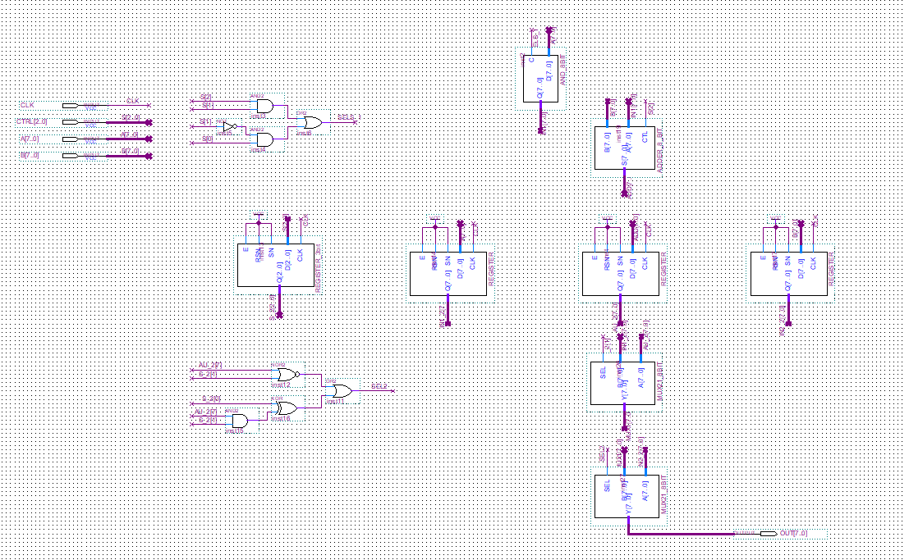

+đóng gói:

** Lắp ráp datapath:

+schematic:

+đóng gói:

1. **Thiết kế khối controller**

*SƠ ĐỒ KHỐI CÁC BƯỚC THỰC HIỆN THUẬT TOÁN

**\*\*Sơ đồ chuyển trạng thái**

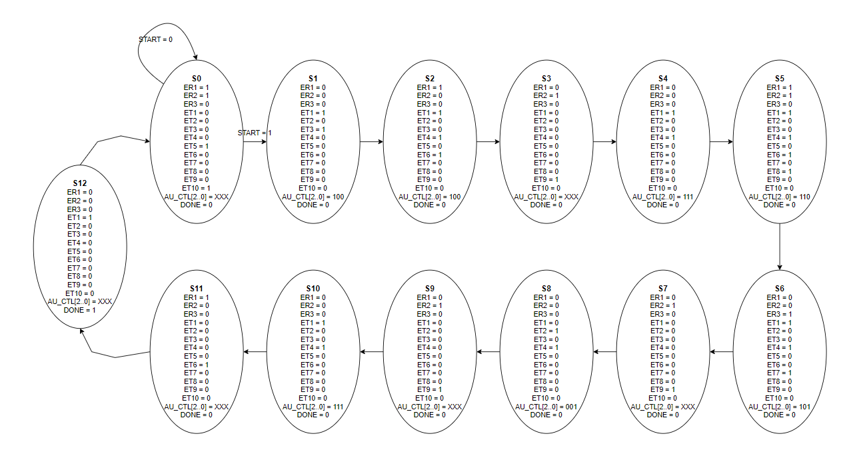

**\* BẢNG CHUYỂN TRẠNG THÁI:**

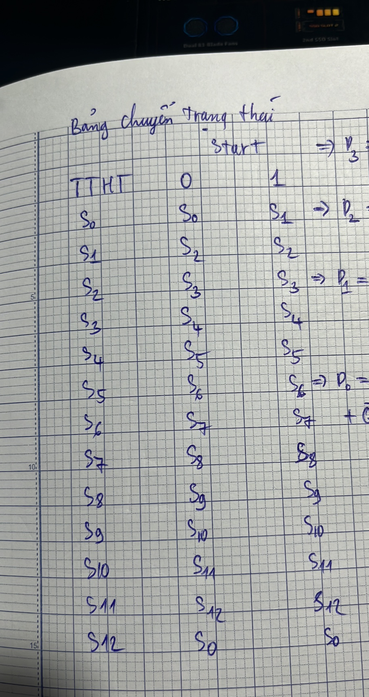

**\*\*MÃ HÓA TRẠNG THÁI:**

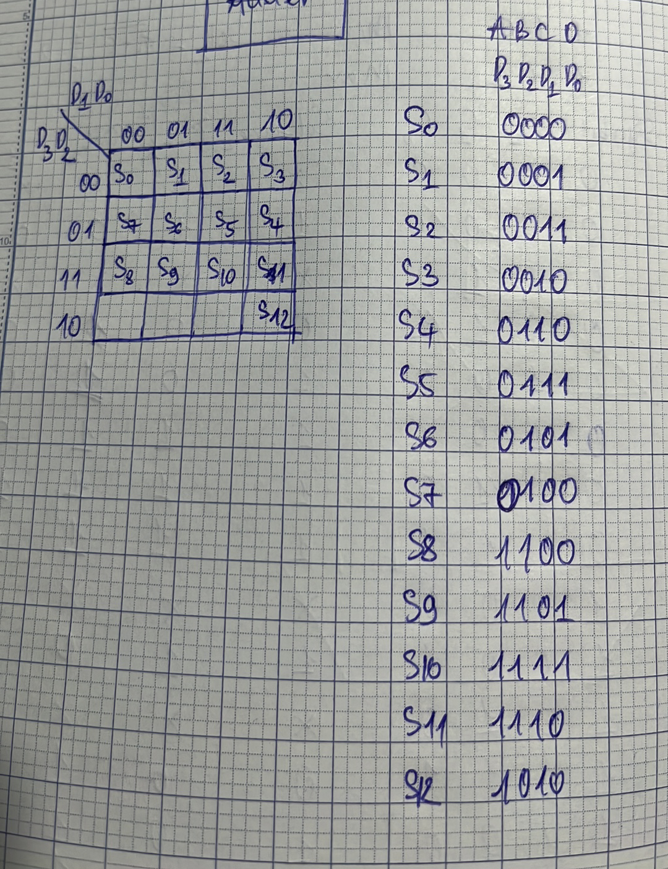

**\*\*\* THIẾT KẾ KHỐI TẠO TTKT**

+ NGÕ VÀO CÁC FF

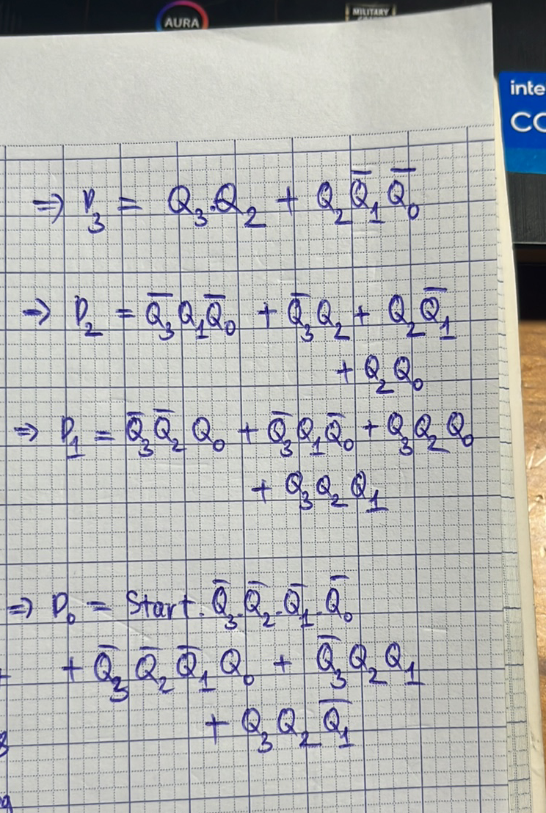

+ SCHEMATIC

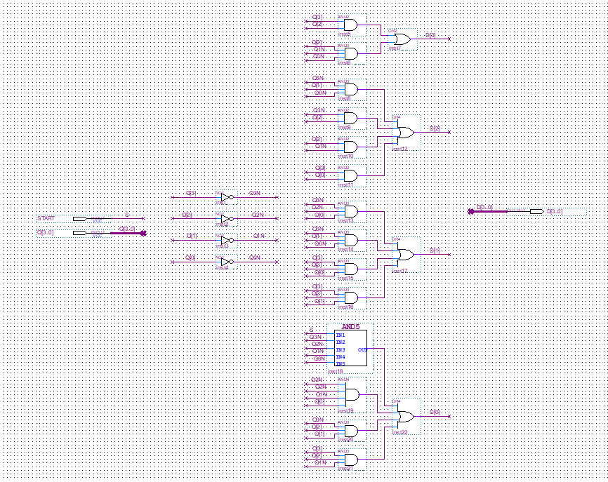

+ ĐÓNG GÓI

**\*\*\*\* THIẾT KẾ KHỐI LƯU TRỮ TTHT**

-TA DÙNG DFF

+SCHEMATIC:

+ĐÓNG GÓI:

**\*\*\*\*\*THIẾT KẾ KHỐI TẠO OUTPUT**

+BẢNG SỰ THẬT CỦA CÁC NGÕ RA

|  |  |  |  |  |  |  |  |  |  |  |  |  |  |  |  |  |  |  |
| --- | --- | --- | --- | --- | --- | --- | --- | --- | --- | --- | --- | --- | --- | --- | --- | --- | --- | --- |
| TT | MH | ER1 | ER2 | ER3 | ET1 | ET2 | ET3 | ET4 | ET5 | ET6 | ET7 | ET8 | ET9 | ET10 | AU[2] | AU[1] | AU[0] | DONE |
| S0 | 0000 | 1 | 1 | 0 | 0 | 0 | 0 | 0 | 1 | 0 | 0 | 0 | 0 | 1 | X | X | X | 0 |
| S1 | 0001 | 0 | 0 | 0 | 1 | 0 | 1 | 0 | 0 | 0 | 0 | 0 | 0 | 0 | 1 | 0 | 0 | 0 |
| S2 | 0011 | 1 | 0 | 0 | 1 | 0 | 0 | 1 | 0 | 1 | 0 | 0 | 0 | 0 | 1 | 0 | 0 | 0 |
| S3 | 0010 | 0 | 1 | 0 | 0 | 0 | 0 | 0 | 0 | 0 | 0 | 0 | 1 | 0 | X | X | X | 0 |
| S4 | 0110 | 0 | 0 | 0 | 1 | 0 | 0 | 1 | 0 | 0 | 0 | 0 | 0 | 0 | 1 | 1 | 1 | 0 |
| S5 | 0111 | 1 | 1 | 0 | 1 | 0 | 0 | 1 | 0 | 1 | 0 | 1 | 0 | 0 | 1 | 1 | 0 | 0 |
| S6 | 0101 | 0 | 0 | 1 | 1 | 0 | 0 | 1 | 0 | 0 | 1 | 0 | 0 | 0 | 1 | 0 | 1 | 0 |
| S7 | 0100 | 0 | 1 | 0 | 0 | 0 | 0 | 0 | 0 | 0 | 0 | 0 | 1 | 0 | X | X | X | 0 |
| S8 | 1100 | 0 | 0 | 0 | 0 | 1 | 0 | 1 | 0 | 0 | 0 | 0 | 0 | 0 | 0 | 0 | 1 | 0 |
| S9 | 1101 | 0 | 1 | 0 | 0 | 0 | 0 | 0 | 0 | 0 | 0 | 0 | 1 | 0 | X | X | X | 0 |
| S10 | 1111 | 0 | 0 | 0 | 1 | 0 | 0 | 1 | 0 | 0 | 0 | 0 | 0 | 0 | 1 | 1 | 1 | 0 |
| S11 | 1110 | 1 | 0 | 0 | 0 | 0 | 0 | 0 | 0 | 1 | 0 | 0 | 0 | 0 | X | X | X | 0 |
| S12 | 1010 | 0 | 0 | 0 | 1 | 0 | 0 | 0 | 0 | 0 | 0 | 0 | 0 | 0 | X | X | X | 1 |
|  |  |  |  |  |  |  |  |  |  |  |  |  |  |  |  |  |  |  |

+SCHEMATIC

+ĐÓNG GÓI

**\*\*\*\*\*\*TỔNG HỢP TẠO KHỐI CONTROLLER**

+SCHEMATIC

+ĐÓNG GÓI

**TỔNG HỢP ASIC:**

+SCHEMATIC

+MÔ PHỎNG

